ASSIGNMENT No. 3

Complex Computing Problem
Course Title: Web Engineering
Course Code: SEN-310
Class: BS (CS)-6A Submission deadline: 10-12-25 Course Instructor: Fatima Bashir Marks: 10

__________________________________________________ Instructions
- Students will perform this assignment in group of 2.
- Assignment should be done only on A4 size paper and will also be uploaded on LMS
- Deadline will not be extended for any reason.
- Copied assignments will be marked zero
- Make a single pdf as both soft copies and hard copy
- Solution must be designed by applying the following characteristics

Characteristics | Problem Solving description
Depth of analysis required | Requires Visual Studio, Database (MongoDB), Frontend (React), Backend (Node JS & Express) used to develop web application .
Depth of knowledge required | Html, JavaScript, CSS and MERN Stack fundamentals knowledge would be needed to solve this well-defined computing problem.

1. Scenario
Fruit mStore is a neighborhood-based fresh produce retailer that aims to transition from a manual, paper-driven workflow to a lightweight digital ordering platform. The shop currently manages product availability, customer requests, and order records using handwritten notes, which leads to frequent mistakes such as incorrect totals, misplaced orders, and delayed confirmations.
To streamline operations, Fruit mStore requires a compact but structured MERN-based web application that enables customers to interact with the store digitally while allowing the shop owner to maintain control over product data. The system should simulate the core behaviour of a commercial e-commerce workflow, yet remain limited in scope to ensure timely completion within the development window.
The platform must provide the following capabilities:
- Product Catalogue Display
- Admin-Controlled Product Management:
- Cart Management:
- Order Placement Workflow:
- Dynamic Address Requirement:
- Mock Payment Option
Overall, even though the system is intentionally small, it should appear structured, modular, and reflective of real-world e-commerce functionality, giving students experience with product management, role-based access, checkout logic, and conditional forms—all within a manageable development scope.

2. Assumptions
- The system has different types of users.
- Users can interact with items or products in some way.
- Some users have special privileges to manage the system.
- Users can place orders or requests.
- Orders include relevant information needed to process them.

3. Deliverables
A. Working Application B. Documentation
- Overview of the system
- ERD
- Screenshots of Project
C. Source Code

4. Evaluation Criteria
- Functionality – 50%
- Code Quality – 10%
- UI/UX – 20%
- Documentation – 5%
- Web Security 15%

REPORT
Documentation:
Overview:
Fruit mStore is a neighborhood-based fresh produce retailer that currently relies on a manual, paper-driven workflow to manage product availability, customer orders, and daily sales records. This traditional approach often results in operational issues such as incorrect order totals, misplaced customer requests, delayed confirmations, and difficulty in tracking product data. To address these challenges, this project proposes the development of a lightweight, web-based digital ordering platform using the MERN stack (MongoDB, Express.js, React.js, and Node.js).
The objective of the Fruit mStore system is to digitize core retail operations while keeping the application compact and manageable. The platform is designed to simulate the essential behavior of a real-world e-commerce system, enabling customers to browse available products, manage a shopping cart, and place orders online. At the same time, the system provides the shop owner (admin) with controlled access to manage product listings, update availability, and oversee order records.
The application incorporates role-based access control to distinguish between regular users (customers) and administrative users. Customers can interact with products by viewing details, adding items to a cart, and completing an order through a structured checkout workflow. Administrators have special privileges that allow them to add, update, or remove products from the catalogue, ensuring that inventory data remains accurate and up to date.
To enhance realism while remaining within scope, the system includes features such as dynamic address requirements during checkout and a mock payment option to simulate transaction completion without integrating real payment gateways. Orders store all relevant information required for processing, including selected products, quantities, total cost, delivery details, and order status.
Overall, Fruit mStore aims to provide a structured, modular, and user-friendly web application that reflects real-world e-commerce functionality on a small scale. The project allows students to gain hands-on experience with product management, user roles, cart and checkout logic, and conditional form handling, while transitioning a traditional retail workflow into a modern digital solution.
ERD:
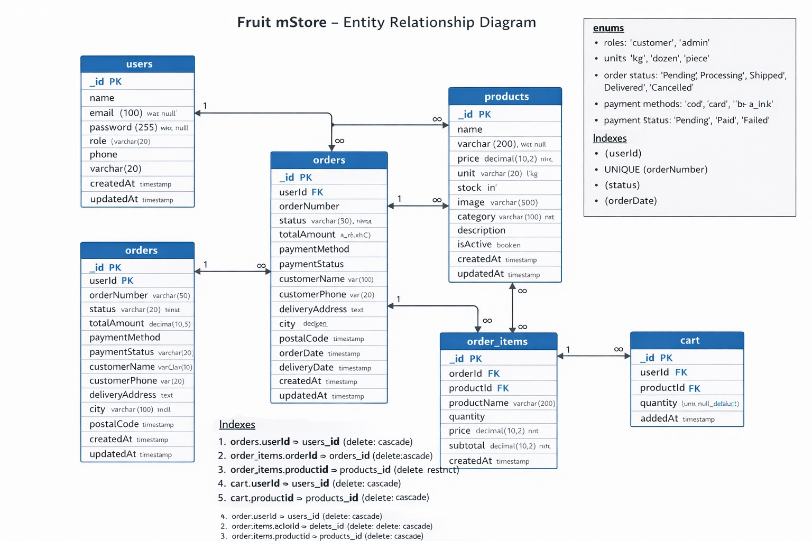

Screenshots of Project:
